Lab H – Securing a Wireless Network

Timothy Victori

Arizona State University

IFT 202

Gary Grindle

9/29/2024

What three recommendations did you choose to follow or simulate following?
- Protect Your SSID - Change the SSID and Hide SSID
- Set up a guest network
- Change the default Passwords
In your own words, describe how implementing these recommendations will improve the security of your wireless network. Elaborate and be descriptive. Assume you were explaining this to a customer who hired you to do this and is watching you and asking you questions but be technical at the same time.
- Changing the SSID from the default and hiding it provides security by obfuscation which makes it (slightly) more difficult for someone to randomly guess my SSID and hiding prevents it from be automatically discovered so a random passerby wouldn’t necessarily know to access the router or attempt to.
- Setting up a guest network causes guests to have a different login than the main one meaning they do not know your main wifi password and malware downloaded by them on their devices will not propagate using the primary network as it is separated from the guest network
- Changing the default passwords prevent people from getting into your settings/router by just googling your router and putting the defaults in and calling it a day.
Screenshot 1 Depicting the SSID change and hiding of the SSID in the wireless Settings menu also Depicts a strong password
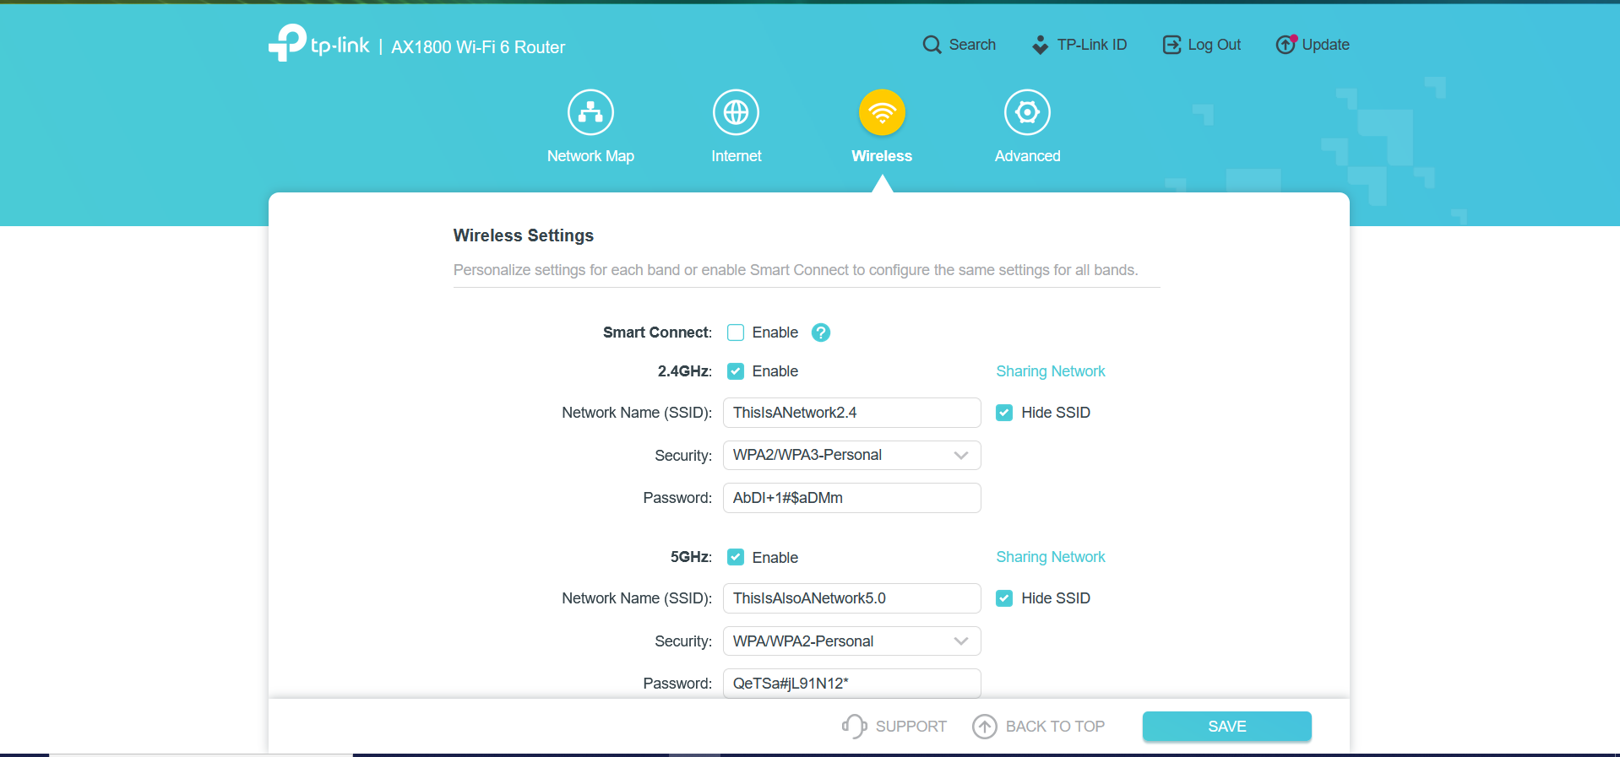
Screenshot 2 depicts 2 guest networks set up
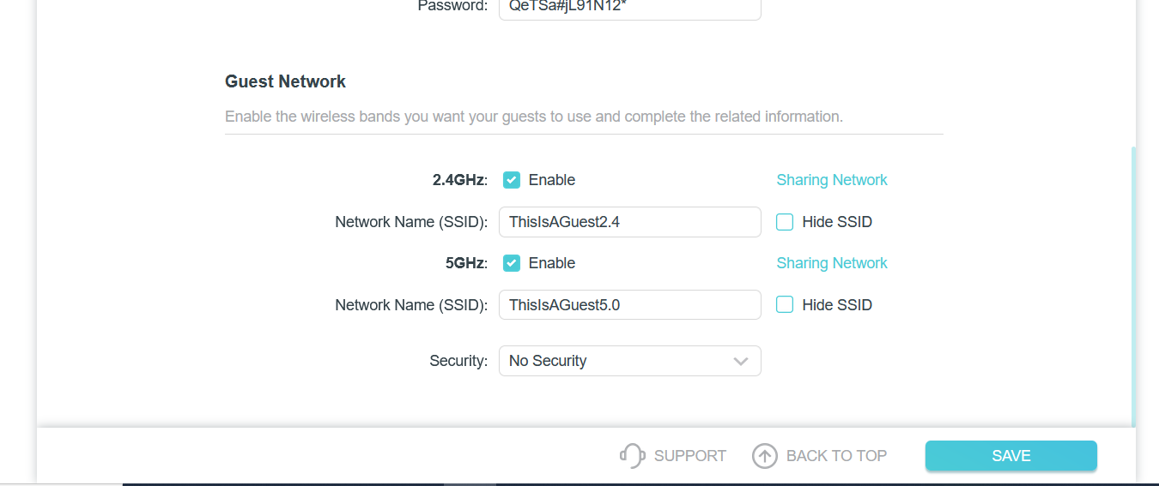
Screenshot 3 showing a strong password for the router’s settings
